Case Study
Hospital Management System
Alishba Azhar: 000925324
Thomas Coons: 000317961
Pouya Tayyari: 000949516
Khushal Parimal Valand: 000922744
Mohawk College
COMP-CO835-09: Object Oriented Systems
Dr. Stanley Ukah
November 30th, 2024

1. Functional Requirements:
- The functional requirements for the Hospital Management System consist of the following:
  - Record Patient Information:
The system must allow the receptionists and business managers to track all necessary information regarding patient information. This involves creating, reading, and updating patient information when necessary. Information such as name, date of birth, gender, and number of visits will be tracked.
  - Record Household Information:
The system must be able to create, read, and update household management information. The system must allow the receptionists and business managers to track information such as name, address, and telephone number, and all necessary insurance information.
  - Enter Payment Information:
The system must allow business managers to enter payment and invoice information accurately when it is received via a patient or insurance company.
  - Generate Invoices:
The system must be able to track and generate invoices for patients and insurance companies. These invoices will include the procedure involved, the patient copay amount, and the total due.
  - Send Invoice to Head of Household:
The system will allow business managers to send invoices to the head of a household at a monthly interval.
  - Send Invoices to Insurance Companies:
The system will allow business managers to send invoices to insurance companies at a weekly interval.
  - Track Overdue Payments and Insurance Claims:
The system will allow the business manager to track overdue payments and print out a report of all households that are behind on payments as well as insurance claims that were successful or denied.
  - Record Details for Patient Procedures:
The system must be able to keep track of patient and staff details when patients are meeting with hospital staff. This information should include what staff were involved with the visit, the patient’s name, the staff member's names, the reason for the procedure / visit, and all necessary insurance information regarding the specific visit associated with the patient involved.
  - Track Employee and Staff Information:
The system will allow the administrators to keep track of hospital staff. This information will include names, addresses, and telephone numbers. This will involve creating, reading, updating, and deleting staff information when necessary.

  - Record Doctor Specific Documentation:
The system must allow for doctors to record, update, and maintain information about patients regarding specific procedures that the doctors were involved in. Doctors will also be able to view the list of procedures they performed during a single week or month. The receptionists will have access to these reports so they can provide the doctors with a report regarding this information.

- Ten use cases from the system using user goal technique:
User | User goal and resulting use case
Receptionist, Business Manager | - View patient details
Receptionist, Business Manager | - View household details
Business Manager | - Enter payment information for specific visits and procedures  - Record payment amount, payment code, and who made the payment (Insurance or Patient).
Business Manager | - Generate invoice reports  - View invoice reports
Business Manager | - Send invoice reports to household
Business Manager | - Send invoice reports to insurance companies
Business Manager | - Monitor overdue payments  - Print reports of successful or denied insurance claims.
Doctor, Nurse, Personal Support Worker | - Record details of the procedures performed into the system  - Save information to the patient’s record for future reference
Administrator | - Manage hospital staff information  - Create, update, or delete hospital staff information
Doctor | - Record details of procedure into the system  - View list of past procedures either weekly or monthly

- Six use cases from the system using event decomposition technique:
Use Case | Type of Event | Trigger | System Response
Record Household Information | External | Receptionist or Business Manager enters or updates household information | The system records or updates the household information as necessary.
Enter Payment Information | External | A patient or insurance company makes a payment. | The receptionist or business manager records the payment information, including the amount received, the patient's co-payment, and any insurance payments or denials.
Send Invoice to Head of Household | Temporal | The system internally tracks monthly intervals of invoices for households. | The system generates and sends invoices to the heads of households and allows business managers to review information before sending.
Send Invoices to Insurance Companies | Temporal | The system internally tracks weekly intervals of invoices for insurance companies | The system generates and sends invoices to insurance companies and allows business managers to review information before sending.
Generate Overdue Payments and Insurance Claims Report | External | Business manager triggers the event when they need to track overdue payments and review insurance claims | The system will generate a report when trigger occurs.
Record Doctor’s Procedure Documentation | External | Doctor updates or records specific patient procedure details they were involved in. | System records and updates patient information. The system will allow new information to be viewed as a report.

- User story showing the business manager generating a monthly invoice for a patient or household:

As a business manager, I want to generate a monthly invoice for a patient or household,
so that I can ensure accurate billing and send the invoice for payment.

2. Use case diagrams showing a complete and comprehensive view of the entire system
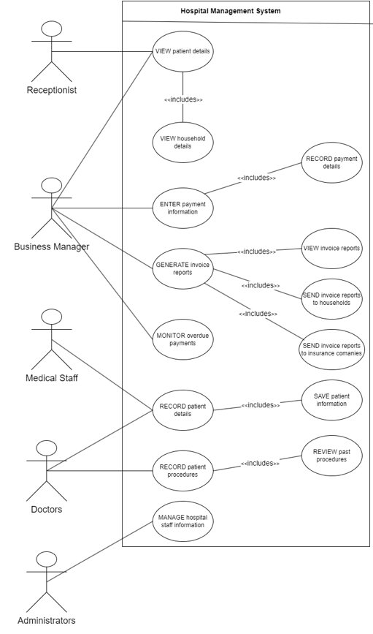

4. Two Activity diagrams for any two use cases associated with the procedures
performed by doctors in the system
Doctor Reviewing Patient Procedure History:
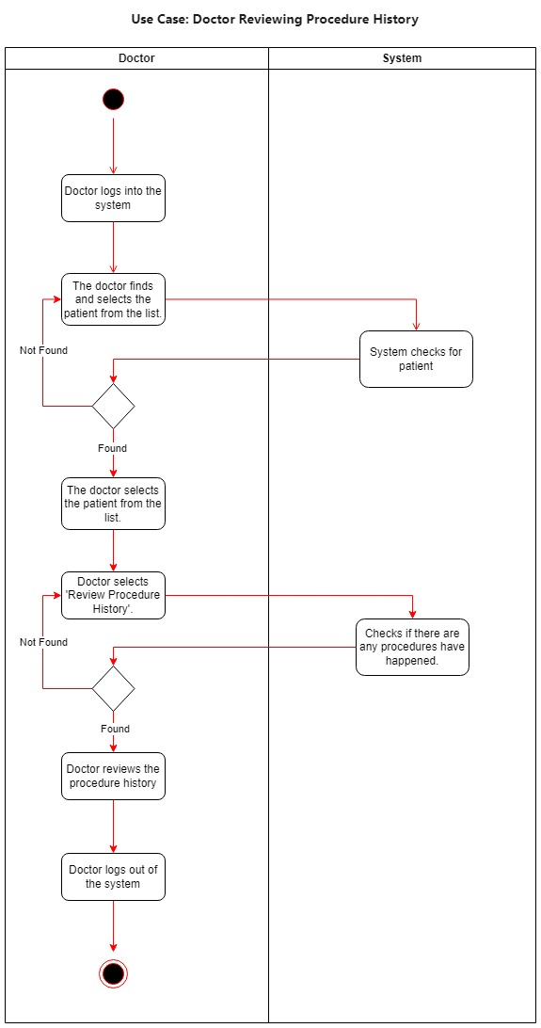

Doctor Creating and Recording Patient Procedure:
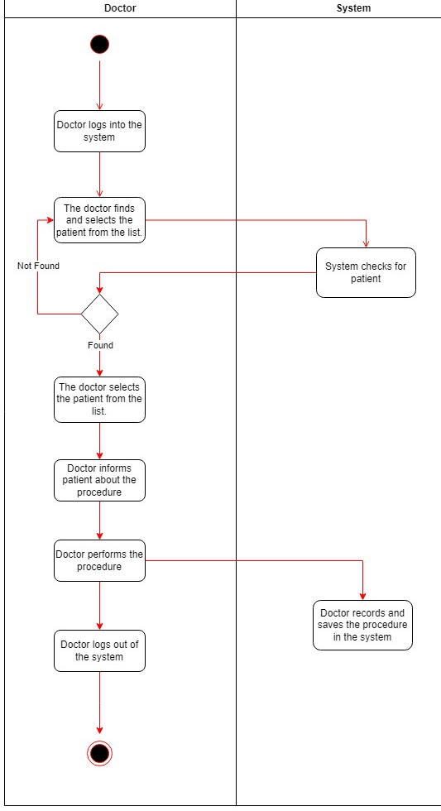

6. State diagrams associated with each of the Use Case description:
